

**Aetrex Integration Guide**

**FOR SALESFORCE COMMERCE CLOUD** 

**Prepared By:**

Aetrex

** Email achoy@aetrex.com**

[**** https://www.aetrex.com](https://www.aetrex.com)

**Table of Contents**

**1. Summary 4**

**2. Component Overview 4**

2.1. Customer Login Page Widget 4

2.2. Product Landing Page Widget 4

2.3. Product Detail Page Widget 4

2.4. Sizeright Widget 5

**3. Implementation Guide 5**

3.1. Overview 5

3.2. Compilation 5

3.3. Installation 5

3.3.1. Add cartridge to cartridge path 5

3.3.2. Import metadata archive 6

3.3.3. Adding API Credentials 8

**4. Operations and Maintenance 8**

4.1. Logs 9

4.2. HTTP Server Availability 9

4.3. Support 9

**5. User Guide 10**

**5.1. Custom Preference 10**

**5.2. Storefront functionality 12**

5.2.1. Customer Login Page Widget 12

5.2.2. Product Landing Page Widget 13

5.2.3. Product Detail Page Widget 14

5.2.4. Sizeright Widget 15

**6. Version and SFRA support info 16**

6.1. JavaScript file and Cartridge Version location 16

6.2. SFRA Version Support 17

6.3. Compatibility Mode 17

**7. Service Errors Handling 17**

7.1. Service Timeout handling 17

7.2. Handle Error response 17

**8. Known Issues 18**

8.1. Test Cases 18

**9. Failover/ Recovery process 18**

# **Summary** horizontal line

This Implementation Guide describes how to integrate **int_fit_genius** configuration cartridges version 18.10 into the Commerce Cloud reference application Store Front Reference Architecture.  
  
  
The cartridge includes:

* Customer Login Page Widget
* Product Landing Page Widget
* Product Detail Page Widget



# **Component Overview**

## **Customer Login Page Widget**

Customer scans are identified using the Unique Customer Identifier that was entered into the Albert scanner at the time of scanning. Which is an email. .

## **Product Landing Page Widget**

This widget provides the FitGenius score for a given shoe style.

## **Product Detail Page Widget**

The product detail page requires 2 widgets to be placed. The first is the ‘aetrex fitgenius score container’ div used in the PLP.

## **Sizeright Widget**

Aetrex SizeRight is a mobile app that uses the camera on a mobile phone to let custom-ers obtain their accurate shoe size



# **Implementation Guide**

## **Overview**

One cartridge support this integration:

* **int_fit_genius** – Commerce Cloud storefront extension

## **Compilation**

Compilation steps for int_fit_genius cartridge

* Open the root directory of the cartridge in a terminal or a command prompt
* Run the following commands with the recommended node version 14.17.0
* npm install
* npm run compile: js
* npm run compile: scss

## **Installation**

### **Add cartridge to cartridge path**

Add **int_fit_genius** into the cartridge path of a target site. To do so, go to **Business Manager > Administration > Sites > Manage Sites > Your Site > Settings** and insert int_fit_genius before your cartridge's record, as shown in **Figure 1**.

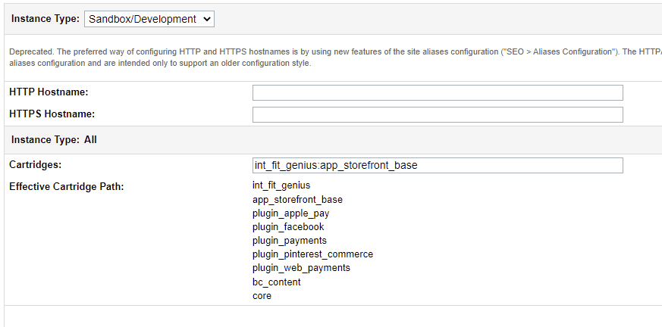  
  **Figure 1. Cartridge Path**

### **Import metadata archive**

Upload and import meta.zip from the metadata folder. To do so, go to **Business Manager > Administration > Site Development > Site Import & Export**. Upload the archive using the Local option in the Upload Archive section. After uploading, choose metadata.zip in the list and click on the import button.

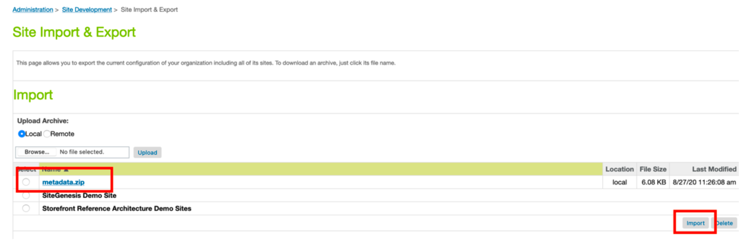  
 **Figure 2: Metadata**

**Snippets**The last part of the cartridge setup is adding some snippets to website template files to enable the cartridge to communicate with the site. There are three templates to be included to show the snippets

* Add the following code in the dashboardProfileCards.isml file:

| <isinclude template="widgets/loginPageWidget"/> |
| --- |

* Add the following code in the productTile.isml file:

| <isinclude template="widgets/categoryPageWidget" /> |
| --- |

Category page widget which displays fit-genius scores.

*Make sure to add the following scripts on the template which is rendering the category landing page.

<isinclude template="widgets/categoryPageWidget" />

assets.addCss('https://aetrex-fit-genius-widgets.s3.amazonaws.com/client/aetrex/fitgenius_widget.css');

assets.addJs('https://aetrex-fit-genius-widgets.s3.amazonaws.com/client/aetrex/fitgenius_widget.js');

* Add the following code in the productDetails.isml file

| <isinclude template="widgets/productDetailsPageWidget"/> |
| --- |

**Administrator > Code Deployment**   
Reinitialize the active code version in which the cartridge resides.  
After the Metadata has been Imported, you need to add your site to the executive scope.

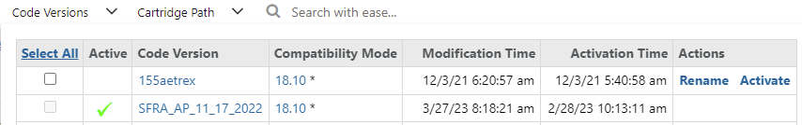  
  
 **Figure 3: Code Version and Executive Scope**

### **Adding API Credentials**

Services:

* ***int_fitgenius.score.http.rest***

To access credentials, go to **Business Manager > Administration > Operations > Services > Credentials**.  
  
You need to fill in the next credentials with the same data:

* **int_fitgenius.score.http.rest**  
   Profile :- int_fitgenius.score.profile  
  Credential :- int_fitgenius.score.credentials

**NOTE**: If you want to create a customer for testing the integration, you need to create the customer with the email address: marz@aetrex.com

# **Operations and Maintenance**horizontal line

## **Logs**

This integration introduces one new custom log:

* Fit Genius Storefront Custom logs – starts with prefix.custom-fitGenius-Logs. This log file contains all the successful request logs.
* Service communication logs – starts with service-fit-genius. These logs contain every service timeout error.

## **HTTP Server Availability**

You can track availability and downtime by service status in the Commerce Cloud Business Manager. Go to **Administration > Operations > Services > service_name**

* int_fitgenius.score.http.rest - To get the Fit Genius score on the category landing page

## **Support**

To get help and support from **Fit Genius**, you can reach out to us on

* **Fit Genius Email support - Email achoy@aetrex.com**
* **Fit Genius Website −Website link** <https://www.aetrex.com>

# **User Guide** horizontal line

## **Custom Preference**

All the Custom preferences   
**Merchant tools>Site preferences>custom preferences>Custom Site Preference Groups>FitgeniusWidgets**

| ***Preference*** | ***Purpose*** | ***Default Values (for Testing)*** |
| --- | --- | --- |
| fitGeniusScoreCategories | Used to define the categories on which the fit genius score is displayed. Define the categories on which you want to display the size right toggle, as shown in Figure 5 |  |
| fitGeniusFootScore | Toggle to display the foot score on the Product Listing Page | yes |
| fitGeniusProfile | Toggle to display the fit genius profile on the login page | yes |
| fitGeniusFootProfile | Toggle to display the foot profile on the Product Details Page. | yes |
| fitGeniusDomain | To fetch the product data | aetrex.com |
| widgetButtonColor | Define color scheme of the widgets | #6D1919 |
| widgetFontColor | Define font color of the widgets | white |
| sizeRightWidget | Toggle to size right | yes |
| integrationMode | To toggle for testing mode | Test (test) |

**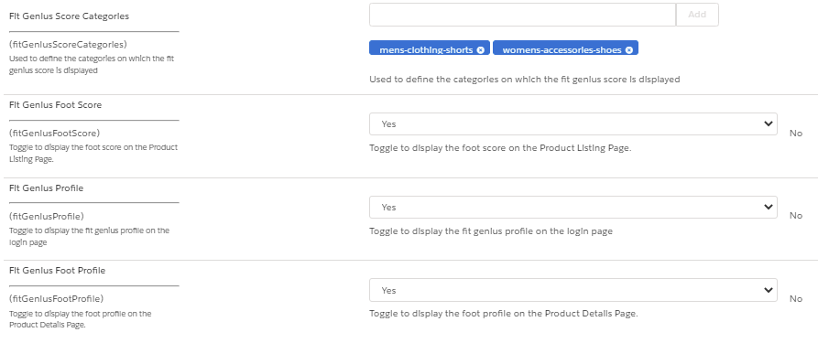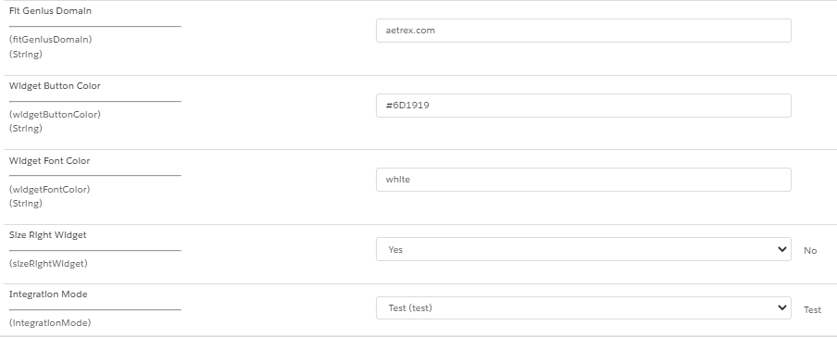  
 Figure 4: Custom Preferences**

  
 **Figure 5**

## **Storefront functionality**

### **Customer Login Page Widget**

Customer scans are identified using the Unique Customer Identifier that was entered into the Albert scanner at the time of scanning. This will be an Email. When a customer visits the website and signs in, the retailer website pass the customer contact information that is used at their scanners to the Aetrex ‘aetrex_profile_container’ div. The output widget would look something like Figure: 6 and can be placed at a location of the retailer’s choice on their website. Aetrex has placed this widget on the page after a customer signs in, as shown Figure: 7

If the customer that logs in has not had an Albert 2 scan, the widget will instead render a scanner locator experience.  
If the customer has undergone a scan in the store then his profile would be visible otherwise scanner locator widget would be displayed

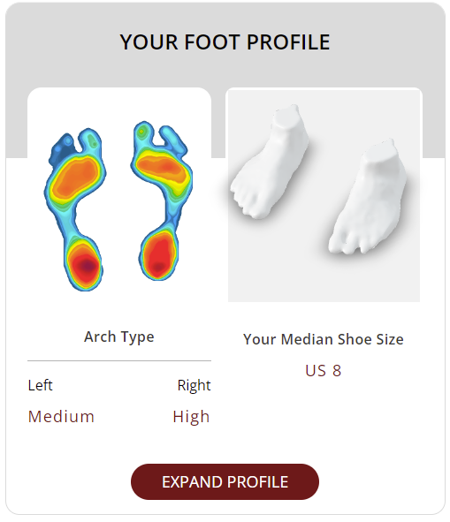

**Figure 6**

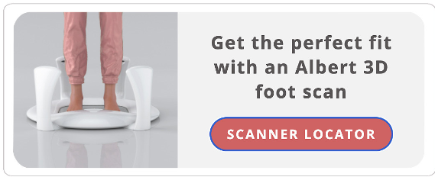  
 **Figure 7**

### **Product Landing Page Widget**

This widget provides the FitGenius score for a given shoe style. The ‘aetrex fitgeniusscore container’ div requires the user’s email, the domain of the site making the call, and the SKU. Since each style can have a unique score, this div must be placed on each and every shoe style block on a given page. The SKU being passed must match the SKU being passed into the FitGenius program’s integration. The SKU being used is typically the group id as found in a product catalog Google feed as shown in figure 8.

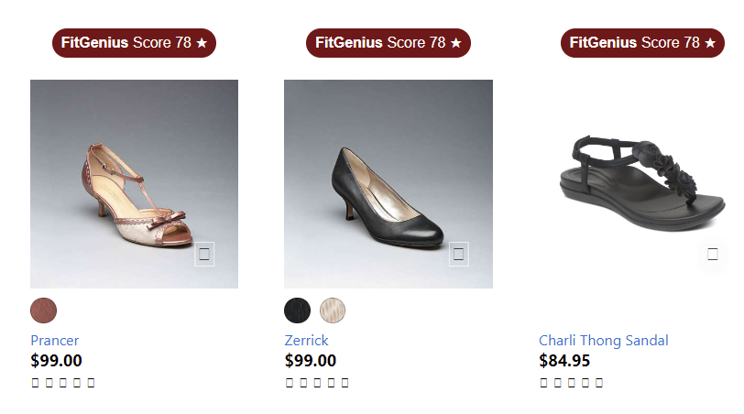  
 **Figure 8**

Depending on the confidence level of the FitGenius AI, one of three things will appear on this widget:

* High confidence will display a FitGenius Score
* Low confidence will display FitGenius Recommended
* No confidence will display nothing

### **Product Detail Page Widget**

The product detail page requires 2 widgets to be placed. The first is the ‘aetrex fitgenius score container’ div used in the PLP. This div (and all its required attributes) is typically placed below the product title. Next is the ‘aetrex foot profile container’ div (different from ‘aetrex profile container’ div) which should be placed below the color selection of the page. This widget experience provides the customer with the FitGenius score for the particular style they are looking at, as well as their foot profile data and recommended size. An example of this integration is shown in figure: 9.

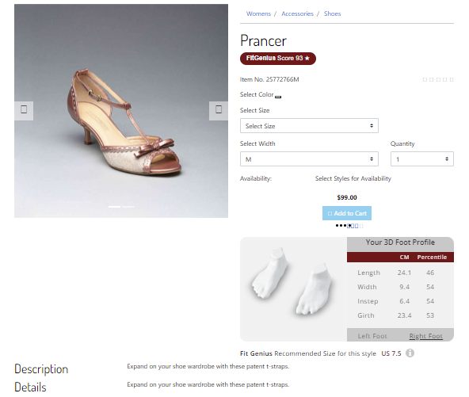  
 **Figure: 9**

### **Sizeright Widget**

Aetrex SizeRight is a mobile app that uses the camera on a mobile phone to let customers obtain their accurate shoe size It is available on the App Store, Play Store, and also browser-based web application. The web app form of this product can be integrated directly into the retailer’s eCommerce site.

Once SizeRight has been integrated into your website, customers visiting your website on a mobile device can choose to obtain their median shoe size and can be presented with a widget based on the SizeRight web app Upon completing the measurements, the data is passed back to your website allowing you to present the best fitting sizes for each style.

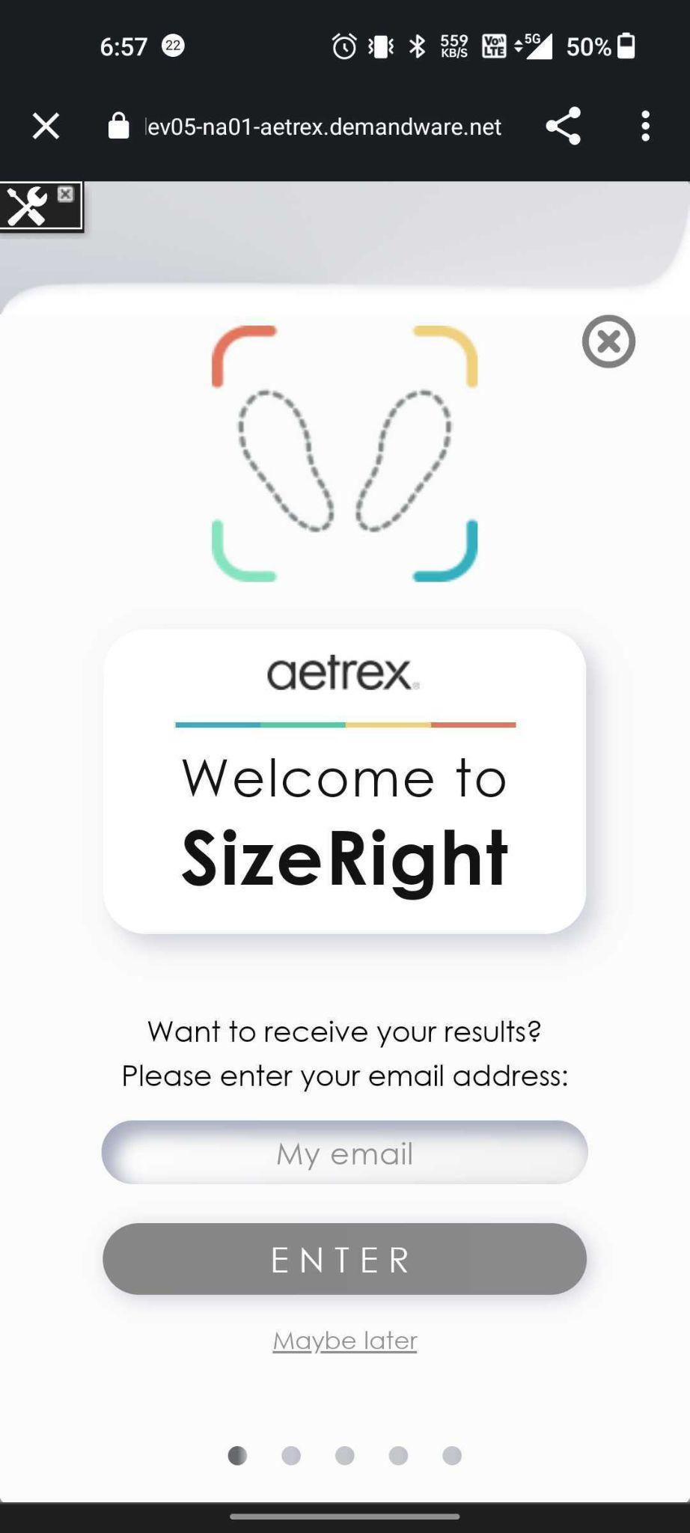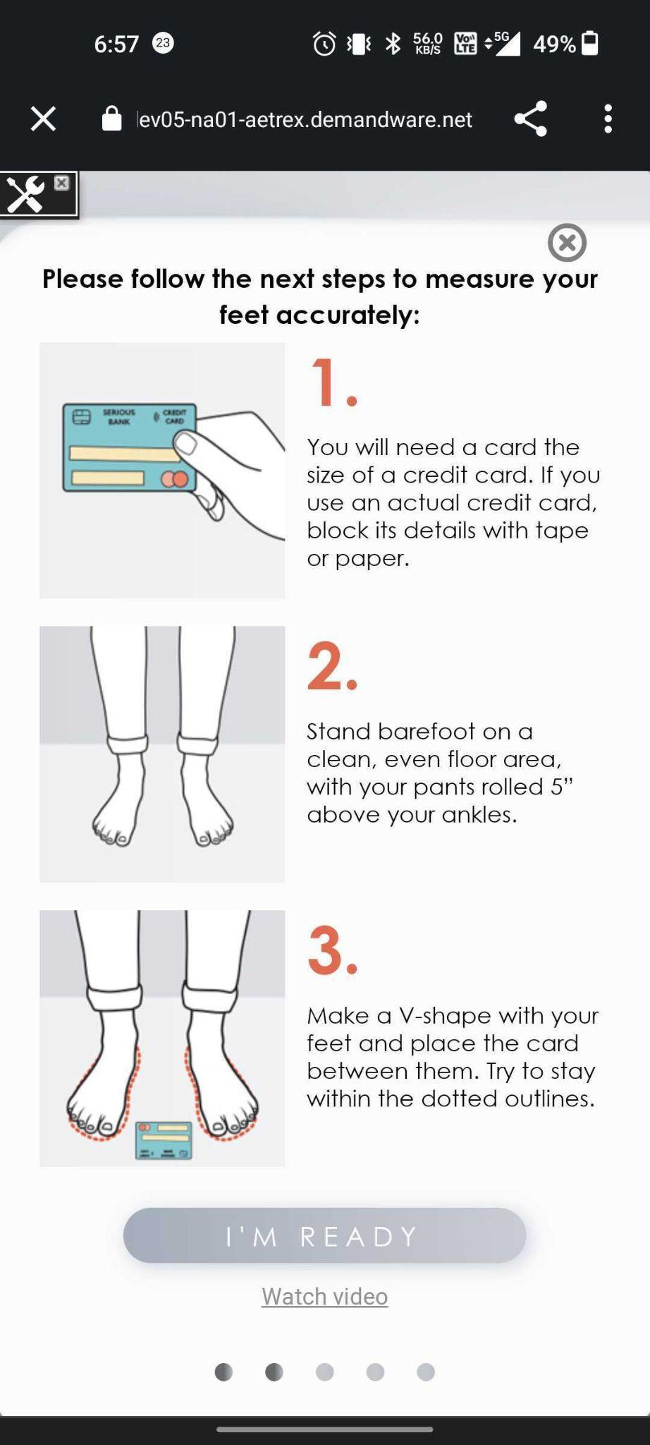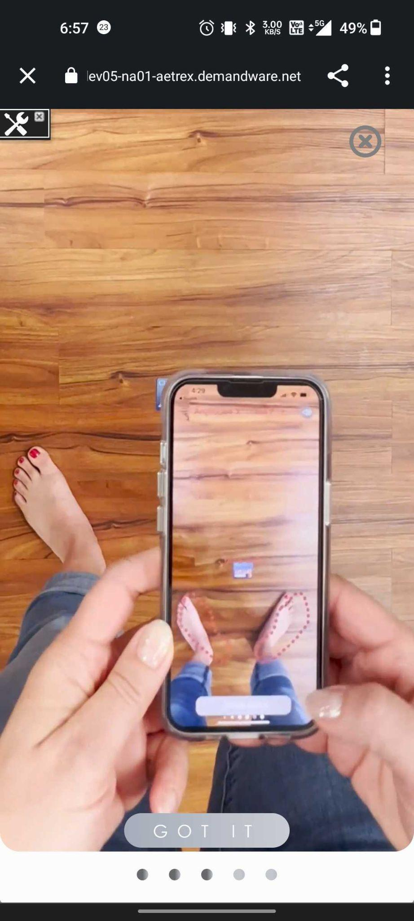  
 **Figure 10**

# **Version and SFRA support info**horizontal line

## **JavaScript file and Cartridge Version location**

* The JavaScript Files are located at:  
  **Cartridges\int_fit_genius \cartridge\client\default\js\**
* The file with the current version of the _______ cartridge is located at   
  **int_fit_genius\cartridge\templates\resources\fitGenius_version.properties**
* The file with the current version of the SFRA cartridge is located at

## **SFRA Version Support**

Fit Genius cartridge version 18.10 supports SFRA 6.0 only.

## **Compatibility Mode**

Cartridge tested with Compatibility Mode 22..

# **Service Errors Handling** horizontal line

## **Service Timeout handling**

If the Fit Genius service becomes unavailable, error details can be found in the following logs:

* Error details can be found in the log with the **custom.fitGenius-errors** prefix.
* Service requests can be found in the log with the **custom.fitGenius-Logs** prefix.  
    
  For more details about logs, see the Logs section.

## **Handle Error response**

Error handling in the integration based on SFRA build in fitGeniusErrors.properties.

* Detailed errors from the Fit Genius can be found in custom-fitGenius-errors.
* All errors text located at: int_fit_genius\cartridge\templates\resources\fitGeniusErrors.properties.

# **Known Issues** horizontal line

No Reported Issues so far. Please Report any issue at

**\**

# **Failover/ Recovery process** horizontal line

In case of any technical failures or issues in processing communication with the servers please contact us on our support email at achoy@aetrex.com  
  
 …